Energy, Work, and Power Review
Test Dates: Black – 11/16/17, Gold – 11/17/17

- Define Potential Energy - __________________________________________________________

- Name each variable and units in the following equation
$$PE=mgh$$

- Ramiro is sitting at the top of a waterslide that is 12 m high. If his mass is 85 kg, what is his potential energy?

- Define Kinetic Energy - ____________________________________________________________

- Name each variable and units in the following equation

$$KE=\frac{1}{2}mv^{2}$$

- A baby bird falls out of its nest at a velocity of 14.7 m/s. If the bird’s mass is 0.114 kg, what is its kinetic energy as it hits the ground?

- How do you find the mechanical energy of a system? ___________________________________
______________________________________________________________________________

- The potential energy of a skier going down a mountain slope is $1.5 × {10}^{5}$J and her kinetic energy is $1.5 × {10}^{5}$J. What is the mechanical energy of the skier?

- Use the following diagram to calculate the potential energy (PE), kinetic energy (KE), mechanical energy (ME), and height (h), and/or velocity (v) at each point.
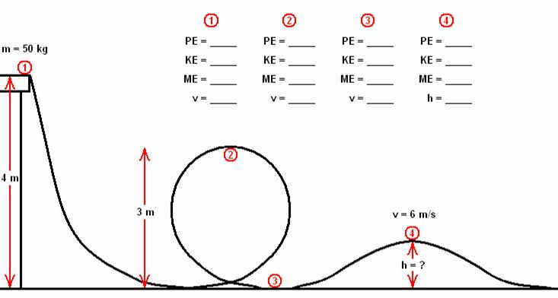

- A skydiver with a mass of 80 kg is on an airplane flying at an altitude of 1,000 m. Neglecting air resistance, how fast will the skydiver strike a soft landing target down below?

- A roller coaster system has a potential energy of 640,000 J at its highest point. How fast will the roller coaster car be traveling at half its height?

- A stone with a mass of 6 kg falls off a cliff that is 120 m tall. What is speed at which it strikes the ground?

